**WELCOME**

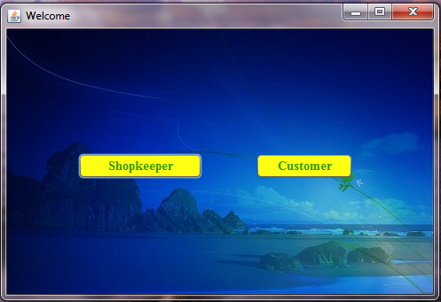

**CREATE NEW ACCOUNT (SHOPKEEPER)**

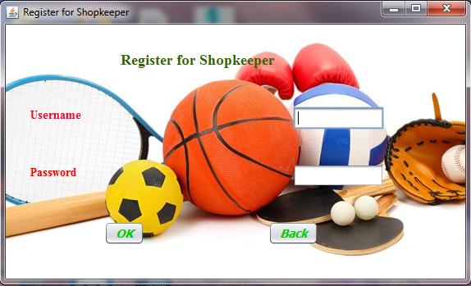

**LOGIN PAGE FOR SHOPKEEPER**

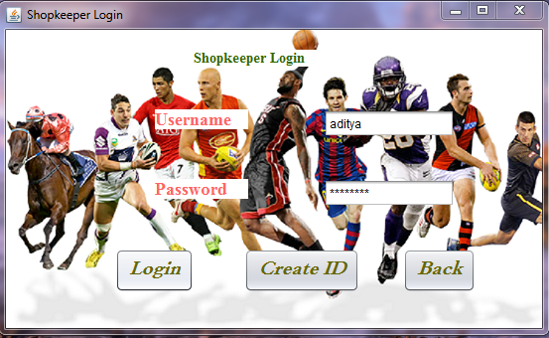

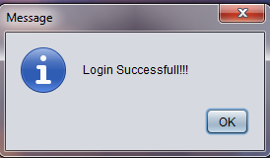

**WELCOME SHOPKEEPER**

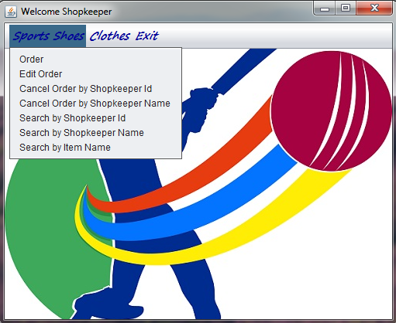

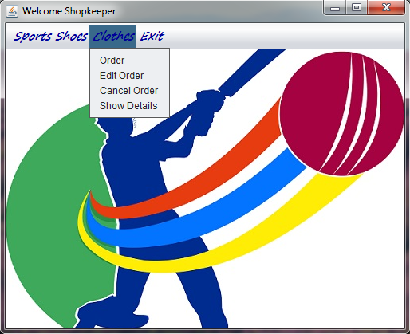

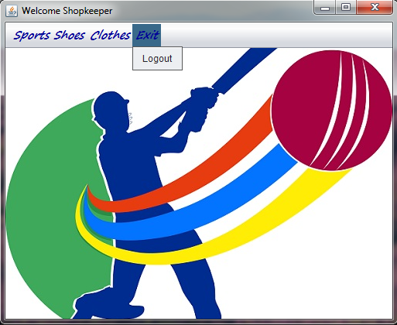

**ORDER CLOTHES**

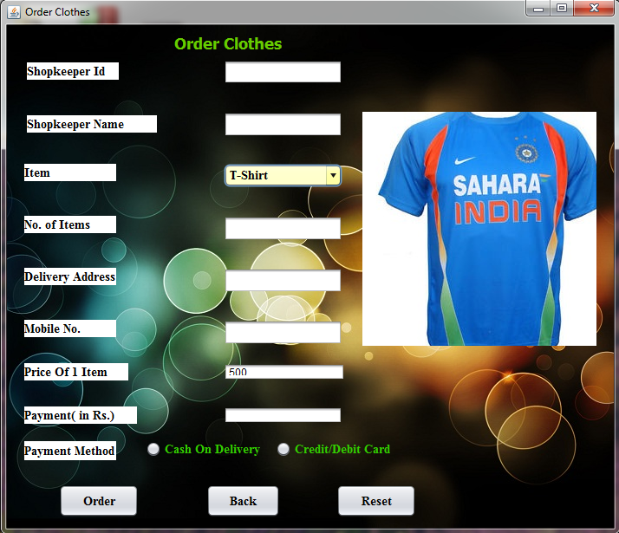

**UPDATE CLOTHES ORDER**

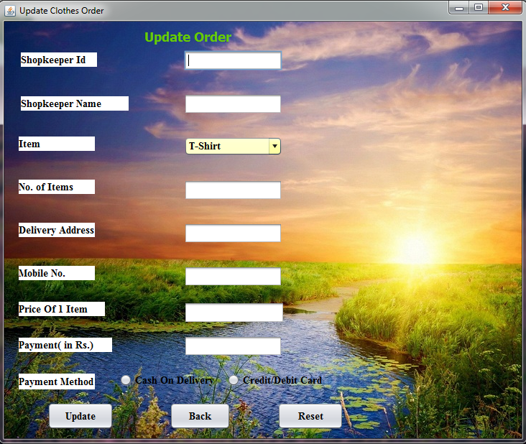

**CANCEL CLOTHES ORDER**

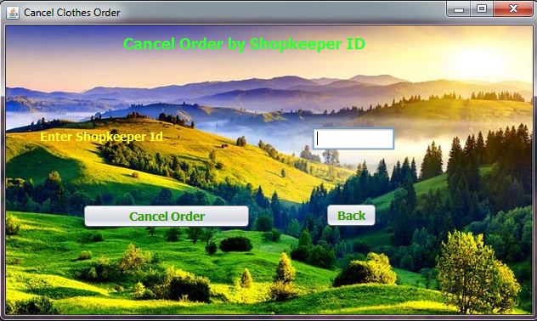

**SHOW CLOTHES DETAILS**

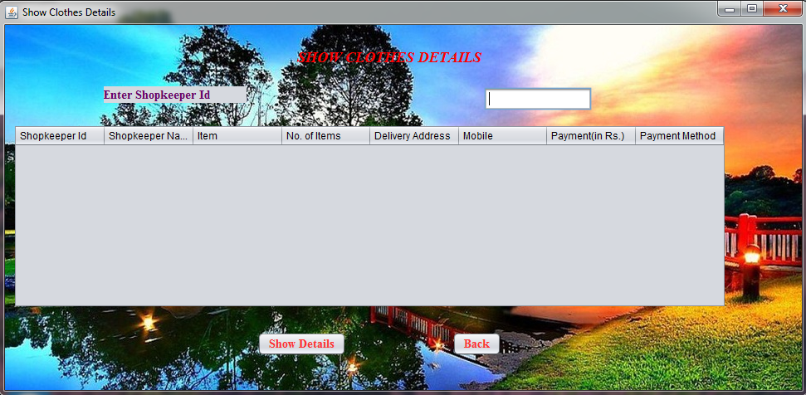

**ORDER AN ITEM**

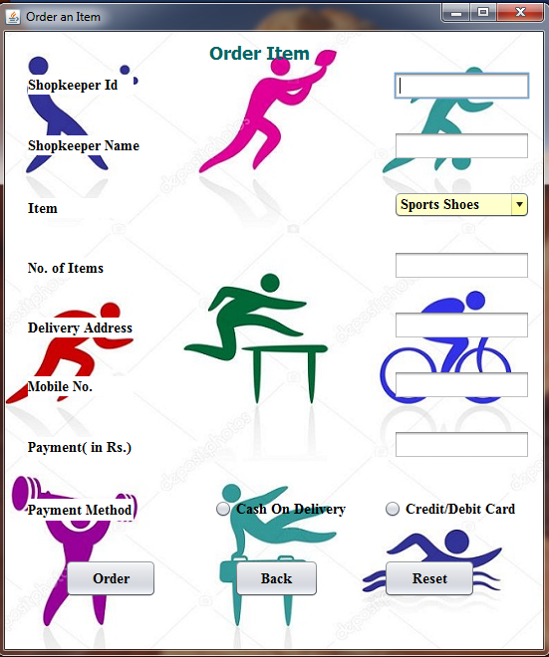

**UPDATE DETAILS**

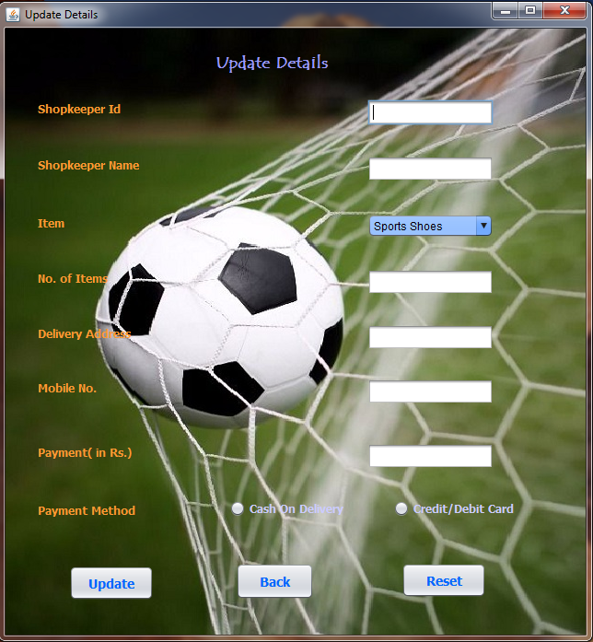

**CANCEL ORDER BY SHOPKEEPER ID**

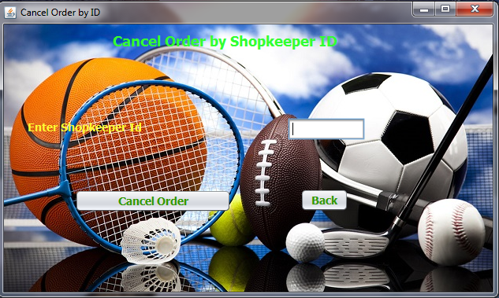

**CANCEL ORDER BY SHOPKEEPER NAME**

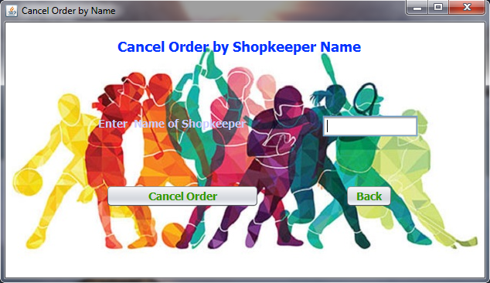

**SEARCH BY SHOPKEEPER ID**

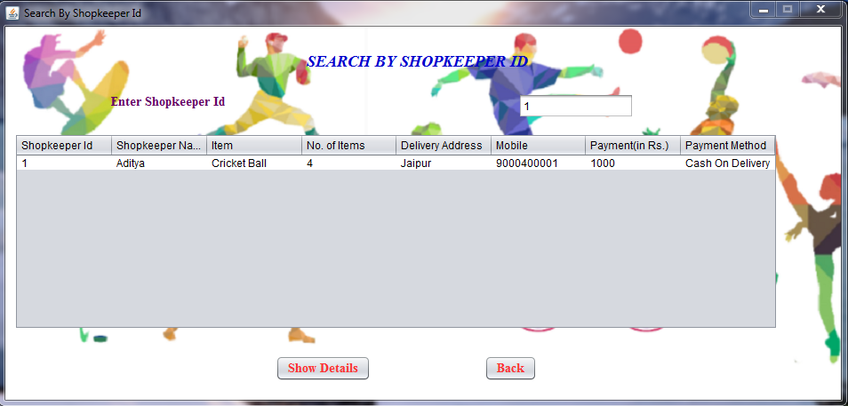

**SEARCH BY SHOPKEEPER NAME**

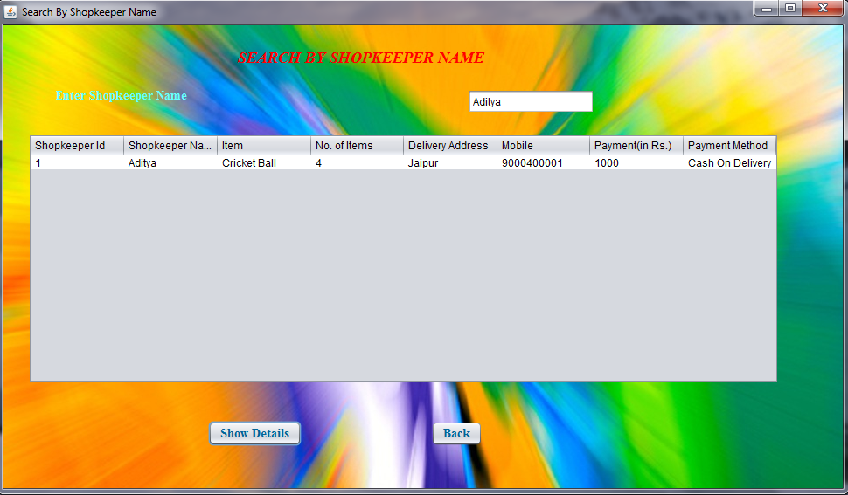

**SEARCH BY ITEM NAME**

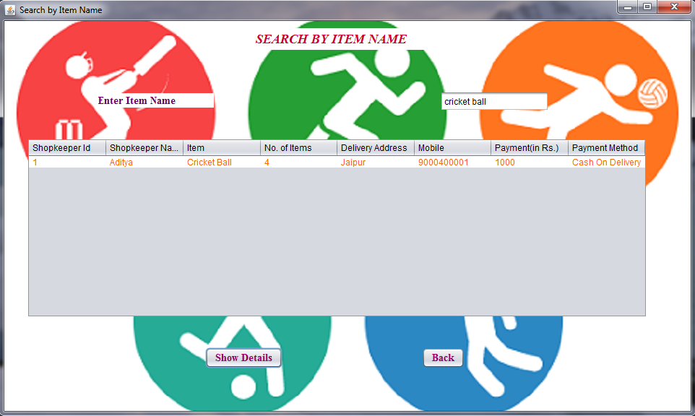

**REGISTER FOR CUSTOMER**

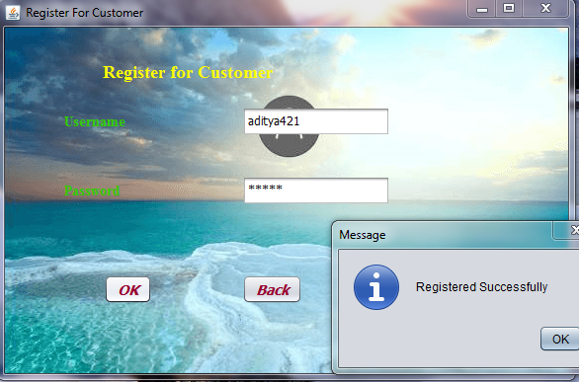

**LOGIN FOR CUSTOMER**

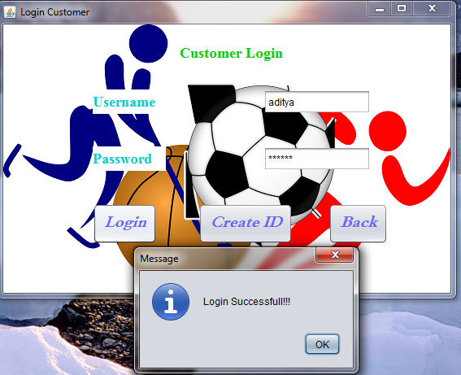

**WELCOME CUSTOMER**



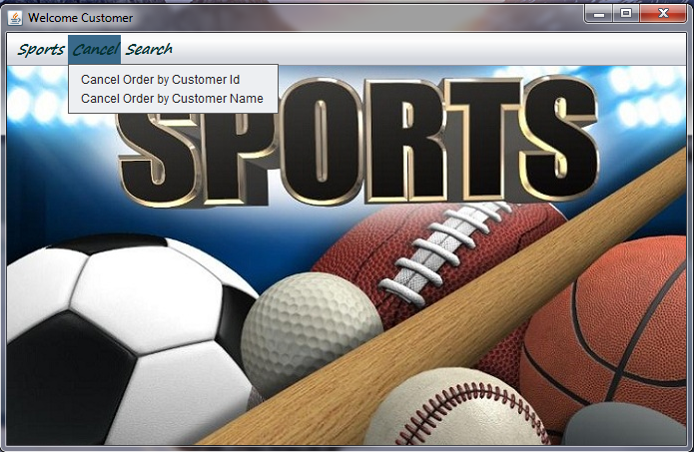

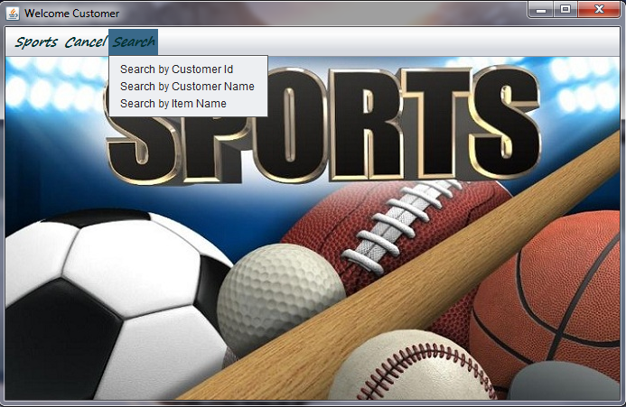

**ORDER ITEM**

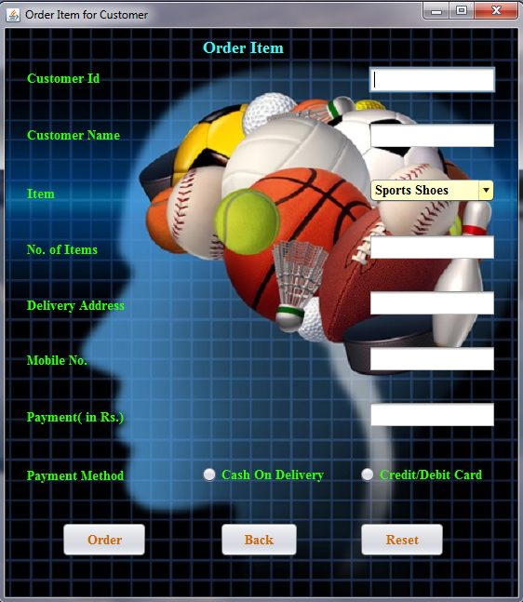

**UPDATE ORDER DETAILS**

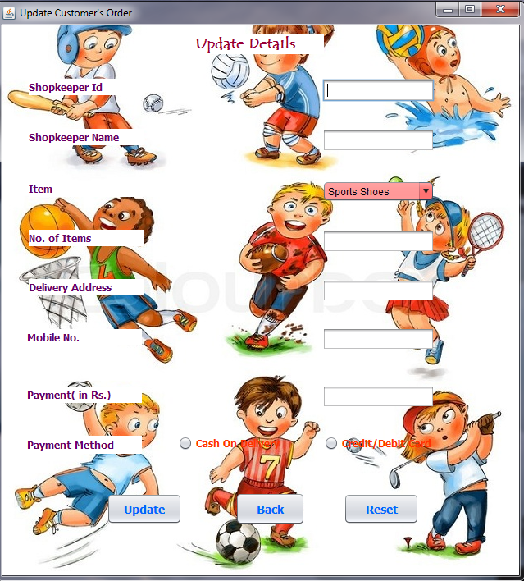

**CANCEL ORDER BY CUSTOMER ID**

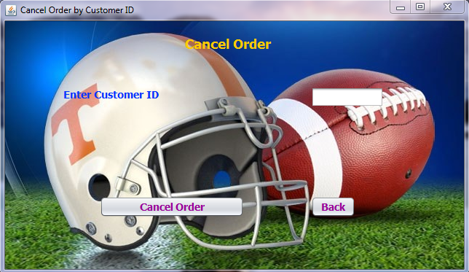

**CANCEL ORDER BY CUSTOMER NAME**

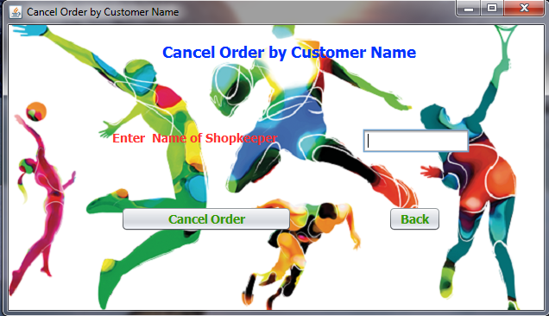

**SEARCH BY CUSTOMER ID**

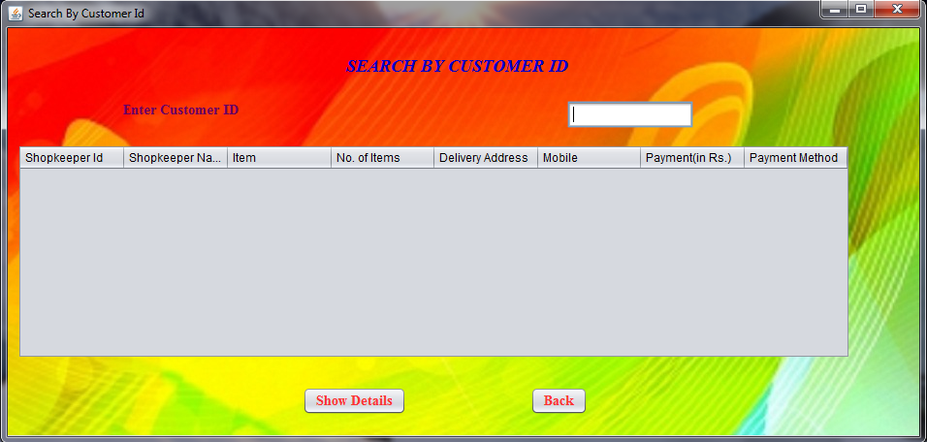

**SEARCH BY CUSTOMER NAME**

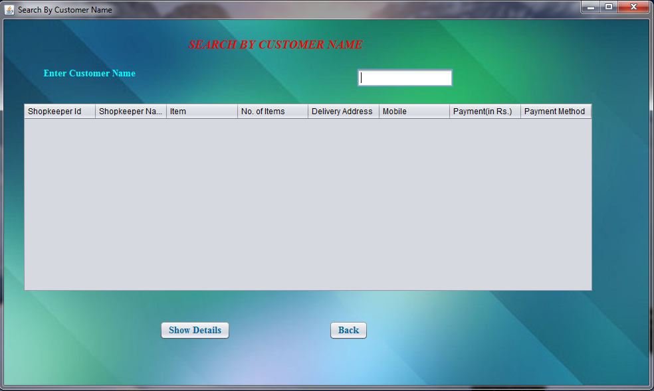

**SEARCH BY ITEM NAME ORDERED BY CUSTOMER**

